FOSWEC2 Repair and Upgrade

Draft

Bret Bosma

4/7/2023

Contents

Introduction 3

Encoder swap 5

Pendulum tests 5

Encoder Comparison 8

EtherCAT network definition 10

Motor checkout with flaps disconnected 10

Flap tensioning 11

Flap Load cell checkout 11

Flap SSI encoder checkout 11

Pressure sensor checkout 11

Motor temperature checkout 13

VRU accelerometer checkout 13

Inverted dry flap reference command 13

Inverted dry flap feedback 16

Graphical User Interface (GUI) development 24

Wave Basin Deployment 26

Wave Basin Testing 27

Summary of FOSWEC2 updates 33

Appendix A 34

# Introduction

This report documents the efforts in repairing and upgrading the FOSWEC2 device. Major efforts include:

* Replacement of motor encoders from analog to digital based design
* Pendulum testing of motors and new encoders to establish torque constants
* Comparison of encoder noise pre and post encoder swap
* EtherCAT network definition and motor checkout without flaps
* Dry tests of flaps in an upside-down configuration of the FOSWEC2
* Repair and recalibration of aft flap 6DOF load cell whose cable was compromised
* Complete update to MATLAB/Simulink operating software to update to new Speedgoat operating system and user interface
* Wave basin testing of the FOSWEC2

Updated system diagram shown in Figure 1.



Figure : Updated FOSWEC2 system diagram

# Encoder swap

A feedback stability issue with the FOSWEC2 deployment in February 2020 was identified and potential solutions explored. One issue identified was encoder noise. The original absolute encoder used on the FOSWEC2 was the Sick SKS36-HFA0-K02 with Hyperface interface. The encoder specs include 128 sine/cosine periods per revolution and 4096 total number of steps. As this is a hybrid analog/digital transducer, it is possibly susceptible to noise from the surrounding environment.

The Heidenhain ECN 1123 512 with EnDat2.2 interface was chosen as a fully digital replacement absolute encoder. This encoder has 23 bits per revolution or 8388608 position values per revolution. Custom adapter pieces were designed and fabricated by Sandia National Laboratories to allow for integration of the new encoder. A cad rendering of these pieces is shown in Figure 2

Figure : Custom adapter parts for new encoders

# Pendulum tests

Pendulum tests were used to verify functionality of the new encoders and verify the torque constant for the motors. These tests are designed to determine the relationship between torque and current. This is necessary and relevant because most motor drives have current as their input and a relationship between commanded current and actual torque measured is desired. For these tests a custom coupler needed to be fabricated connecting the motor to the torque transducer. The rest of the test stand was repurposed from another project. The bench test setup is shown in Figure 3.

Figure : Bench setup of pendulum tests

Ramp tests were conducted to estimate the torque constant with a maximum current of 20A achieved. The test consisted of four ramp events two clockwise and two counterclockwise alternating as shown in Figure 4.

Figure : Torque vs. Time for pendulum ramp tests

The torque-current relationship was plotted for each ramp segment as shown in Figure 5.

Figure : Torque vs. Current relationship used to estimate torque constant

and the MATLAB polyfit command was used to estimate the torque constant. This was done for the four ramp segments and the Kt values averaged. This was then repeated for the Bow motor and the results are summarized in Table 1.

Table : Kt estimates from pendulum tests

|  |  |
| --- | --- |
| Motor | Kt (Nm/A) |
| Aft | 0.9636 |
| Bow | 0.9438 |

The datasheet for the motor (MF0150025 with the 300V winding) lists a torque constant of 1.021 Nm/A +/- 10%, which gives limits of 0.9189 Nm/A and 1.1231 Nm/A. The measured torque constants for the bow and aft motors fall within these limits.

# Encoder Comparison

Initial evaluation of the noise characteristics comparing the old and new encoders position is detailed in this section. Ten seconds of data from dry testing on 12/18/2019 at 12:32:30 was used for the old encoder data. A section of test period where no commands were being issued to the drive was used. For the new encoders a pendulum bench test (aft20amps.mat and bow20amps.mat) from 9/1/2022 and 8/29/2022 respectively was used. Comparison of the time series of the two encoder signals are shown in Figure 6. Time from the two tests have been shifted to be on the same axis. Also, the means have been subtracted from both signals to be on the same rotation scales.

Figure : Comparison of old and new FOSWEC encoders

Comparison of the variance of the signals is shown in Figure 7. While this result is very encouraging, the true test will be when we are applying feedback in an in-water test.

Figure : Variance comparison

# EtherCAT network definition

Because of changes in the Beckhoff module configuration due to changes in encoder needs and redundant modules, the EtherCAT network needed to be redefined. Additionally, addition of the Mini-DAQ to the EtherCAT network will require re-definition. This proved to be a challenge, as getting the TwinCAT software to recognize the network with the two motor drives present and customizing the motor drive inputs and outputs took a lot of trial and error. AMC_AppNote_017.pdf was used as a guide for customizing the AMC EtherCAT network ESI, and eventually a custom network configuration adding drive bus voltage was achieved.

# Motor checkout with flaps disconnected

A Simulink model was created that configures and sends commands to the motors. Timeout errors were present when trying to set the operation mode of both motors at the same time through Simulink, so configuration was set to operation mode 10 which is cyclic torque mode through the DriveWare software. Code was left in Simulink model but commented out. A sinusoidal torque signal of 1A at 1s was sent to both motors with oscillating motion on both motors confirmed. Scaling on motor position was confirmed by commanding zero and manually rotating each motor one rotation and recording position data.

# Flap tensioning

Figure 8 details the methodology for adjusting the belt tension. Any time the belts get removed, the tension should be adjusted upon replacement. It doesn’t need to be real tight, just snug. As you move the flap back and forth, make sure the return side doesn’t have any slack.

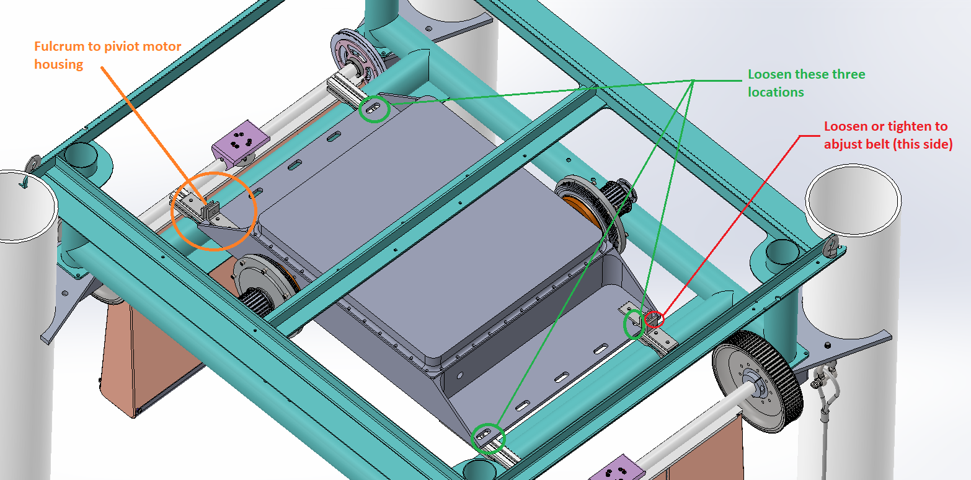

Figure : Methodology for belt tensioning

# Flap Load cell checkout

Checkout of FT30648 on the bow flap indicated a large negative offset in z (~-2500N). The flap and FOSWEC was disconnected from the load cell. While recording, compression force was applied by hand and the offset flipped to positive (~700N). Known weights were applied to the load cell on the bench and reasonable readings around this positive offset were observed. Flap was reconnected and similar positive offset was observed. Simulink model was updated to translate the coordinate system of the load cell into HWRL basin coordinate system.

FT17382 was returned to ATI for repair and calibration and will be integrated when returned.

# Flap SSI encoder checkout

Efforts to incorporate the Flap SSI encoder outputs in the model failed. Configuration in TwinCAT failed to create a scenario where the LED’s indicating valid data on the EL5002 module would light up. Many different configurations were attempted without satisfactory results. I hooked up an oscilloscope to the clock and data signals and they are both showing signals, however movement of the encoder does not induce changes in the count values. Needs further evaluation or change of sensor.

# Pressure sensor checkout

Nominal gains and offsets were used for the pressure gauges due to lack of factory calibration data. A pressure gauge calibration study was undertaken to get an understanding for these nominal gains and offsets.

There is one absolute pressure gauge inside the submerged enclosure. The main purpose of this gauge is monitoring and maintaining pressure inside the submerged enclosure and providing a reference for the gauge sensors in the enclosure. Its model number is TD1200BBA005003D002X and the range is 0-50psi. It is connected to a Beckhoff module EL3154, 4-20mA input. The EL3154 outputs a 16-bit integer. The sign bit is ignored and the range of 0-2^15 corresponds to 4-20mA. Therefore, the conversion from counts to psi is 50/2^15 with no offset.

There are four gauge style pressure sensors measuring the pressure between the inside and outside of the enclosure. These have a model number TDH41BGV01503Q005. Despite the data sheet indicating a range of Vac-15psi for this model number, the range listed on the sensor is -14.7-15 psi. These are connected to a Beckhoff module EL3154, 4-20mA input. The EL3154 outputs a 16-bit integer. The sign bit is ignored and the range of 0-2^15 corresponds to 4-20mA. To verify proper scaling for the sensors a study was conducted. First the performance of the EL3154 was tested. A decade resistance box was connected to the input of the EL3154 and was changed to input a 4-20mA input. The signal read in TwinCAT3 was then verified to be in the range of 0-2^15-1 for this current range as shown in Figure 8.

Next we hooked up one of the pressure sensors to a Fluke 2700G Series Reference Pressure Gauge and a pump and increased the pressure to 15 psi. Pressure was read into Simulink via the EL3154 and displayed in real-time on the screen. A video was taken of both the calibration and Simulink screen as shown in Figure 9. Appendix A gives a summary of the data analyzed. It was determined that using nominal gains was good enough at this time and were assumed as a slope of 29.7/2^15-1, and offset of -14.7.

Figure : Testing the EL3154 by inputting 4-20mA and verifying output in TwinCAT3.

Figure : Recording pressure on calibrator and with Simulink to verify scaling and offset values.

# Motor temperature checkout

Motor temperature was logged using the Beckhoff EL3692 modules and values seemed in a reasonable range and increased when the motor was loaded.

# VRU accelerometer checkout

VRU unit was disconnected from enclosure housing and manually rotated to verify angular positions.

# Inverted dry flap reference command

Current reference signals were sent to the drives to command ramps, sine, white noise, and chirp signals. All were verified to work on the flaps within the range of the flap endstops. Data was collected and stored in the DryReference1 experiment on the HWRL share. Figure 10 shows the inverted dry flap test in progress.

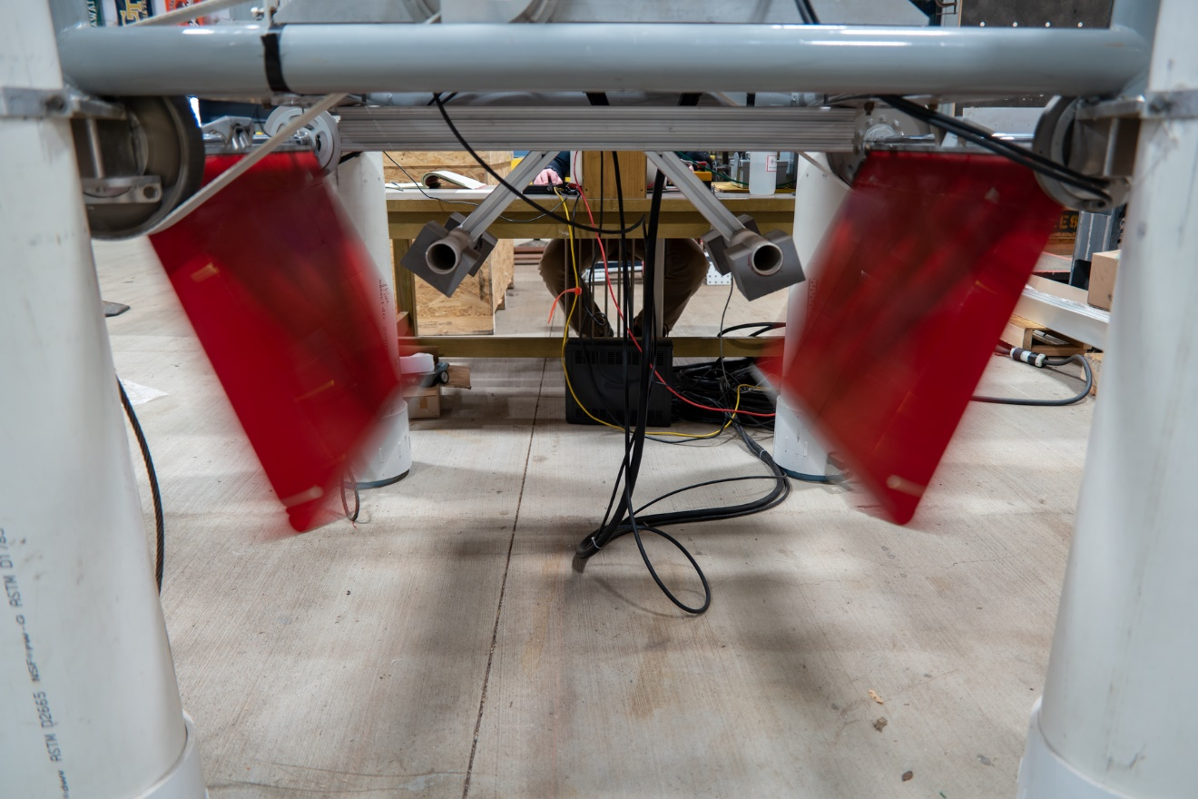

Figure : Inverted flap reference input test

Figure 11 shows the target and actual reported current signal from the motor drive. Motor drive control of current as reported is quite good.

Figure : Reference Current Ramps

Figure 12 shows the target and actual sine wave response from the motor drive. Target matches actual quite well.

Figure : Reference Current Sine

Figure 13 shows the target and actual current for a white noise input. Motor drive controller tracks well.

Figure : Reference Current White Noise

Figure 14 shows the target and actual current fort a chirp input. Motor drive current control tracking well.

Figure : Reference Current Chirp

# Inverted dry flap feedback

Feedback control was implemented to enable the application of velocity and position proportional torque commands. In the control software, conversion from the motor frame to the flap frame is implemented so that damping and stiffness terms are input in the flap frame.

The encoders on the motors are directly connected to the motor drives and the motor drives report the “Position Actual Value”. The software then takes a discrete-time derivative to calculate a velocity. Because of noise in the position signal, both position and velocity feedback signals need to be filtered. Starting with the velocity feedback signal, a 15Hz cutoff frequency first order low pass filter via the discrete transfer function block in Simulink. A second order bandpass filter is applied to the position signal. Velocity proportional feedback control is implemented by sending a current command to the motor drive. Calculation of the current is done with the following:

$$I_{m}=B_{m}ω_{m} B_{m}=\frac{B_{f}}{N^{2}K_{t}} I_{m}=\frac{B_{f}ω_{m}}{N^{2}K_{t}}$$

where $I_{m}(A)$ is the commanded motor torque, $B_{f}\left(\frac{N m s}{rad}\right)$ is the velocity proportional damping term at the flap, $ω_{m}$ is the angular velocity at the motor, $N$ is the gear ratio $\frac{75}{20}=3.75$, and $K_{t}\left(\frac{Nm}{A}\right)$ is the torque constant.

An inverted flap dry test was completed by testing the velocity proportional feedback loop. The flaps were actuated manually with a broomstick as shown in Figure 15. The control loop was activated with an increasing damping value starting at 1 Nms/rad and increasing to 7 Nms/rad. For each damping value the flap was manually actuated several cycles with a broomstick. This test was repeated for the aft and bow flaps and results are shown in Figure 16. Plotted are both the derivative of the drive reported position, and the filtered version of this signal. It is notable that as the applied damping increases, the noise on the motor velocity increases.

Figure : Manual flap actuation to test active feedback

Figure : Inverted flap velocity proportional feedback test

Zooming into one cycle of the bow motor velocity for B = 7 Nms is shown in Figure 17. Even with a fairly aggressive low pass filter, the noise is being transferred through. This results in mechanical resonance in the structure that appears to increase with applied damping.

Figure : Zoomed in bow velocity for B=7 Nms

A longer test with a damping of 7 Nms applied was done and results analyzed in the frequency domain as shown in Figure 18.

Figure : Feedback low pass filter with cutoff 15Hz

The Digital Filter Design block in Simulink was employed to generate a better filter for the velocity feedback. A low pass IIR Maximally Flat filter of 8th order with a sampling frequency of 1 kHz and a cutoff frequency of 10 Hz was chosen as shown in Figure 19. The test was then repeated with the same conditions with the new filter with the results shown in Figure 20.

Figure : Digital Filter design in Simulink

Figure : Updated feedback filter results

The settings for the Digital Filter Design block in Simulink were then modified to try and decrease the phase lag between the filtered and unfiltered velocities. Decreasing the filter order to two for the numerator and denominator seemed a good tradeoff of stability and phase delay. Filter design shown in Figure 21. The resulting frequency plots are shown in Figure 22. The phase lag is significantly decreased while continuing to eliminate the high frequency noise.

Figure : Reducing the filter order to 2 to improve phase lag

Figure : Reduced numerator and denominator filter order to 2 and fc = 10 Hz

A notch filter was then employed to focus on the peak around 54Hz introduced by the second order filter. The “Notch-Peak Filter” block was used with a center frequency of 54.8 Hz and a 3dB Bandwidth specification of 5 Hz.

Figure : Notch plus lowpass filter results

# Graphical User Interface (GUI) development

A graphical user interface was developed using the Matlab toolbox App Designer. This tool allows for creating a user interface that allows for interacting with a model without having to interact with the underlying code. Inputs are available in convenient forms such as sliders, spinners, and text fields and real time monitoring of signals from the output of the system can be displayed in convenient forms including axes, gauges, indicators, etc… As part of the GUI development, at the finish of running the model, the data is retrieved from the Speedgoat system and archived for post processing. A snapshot of the GUI in operation is shown in Figure 23.

Figure : GUI snapshot after white noise reference command

# Wave Basin Deployment

FOSWEC2 was fixed to the basin floor using threaded rod extending through hollow tubes.

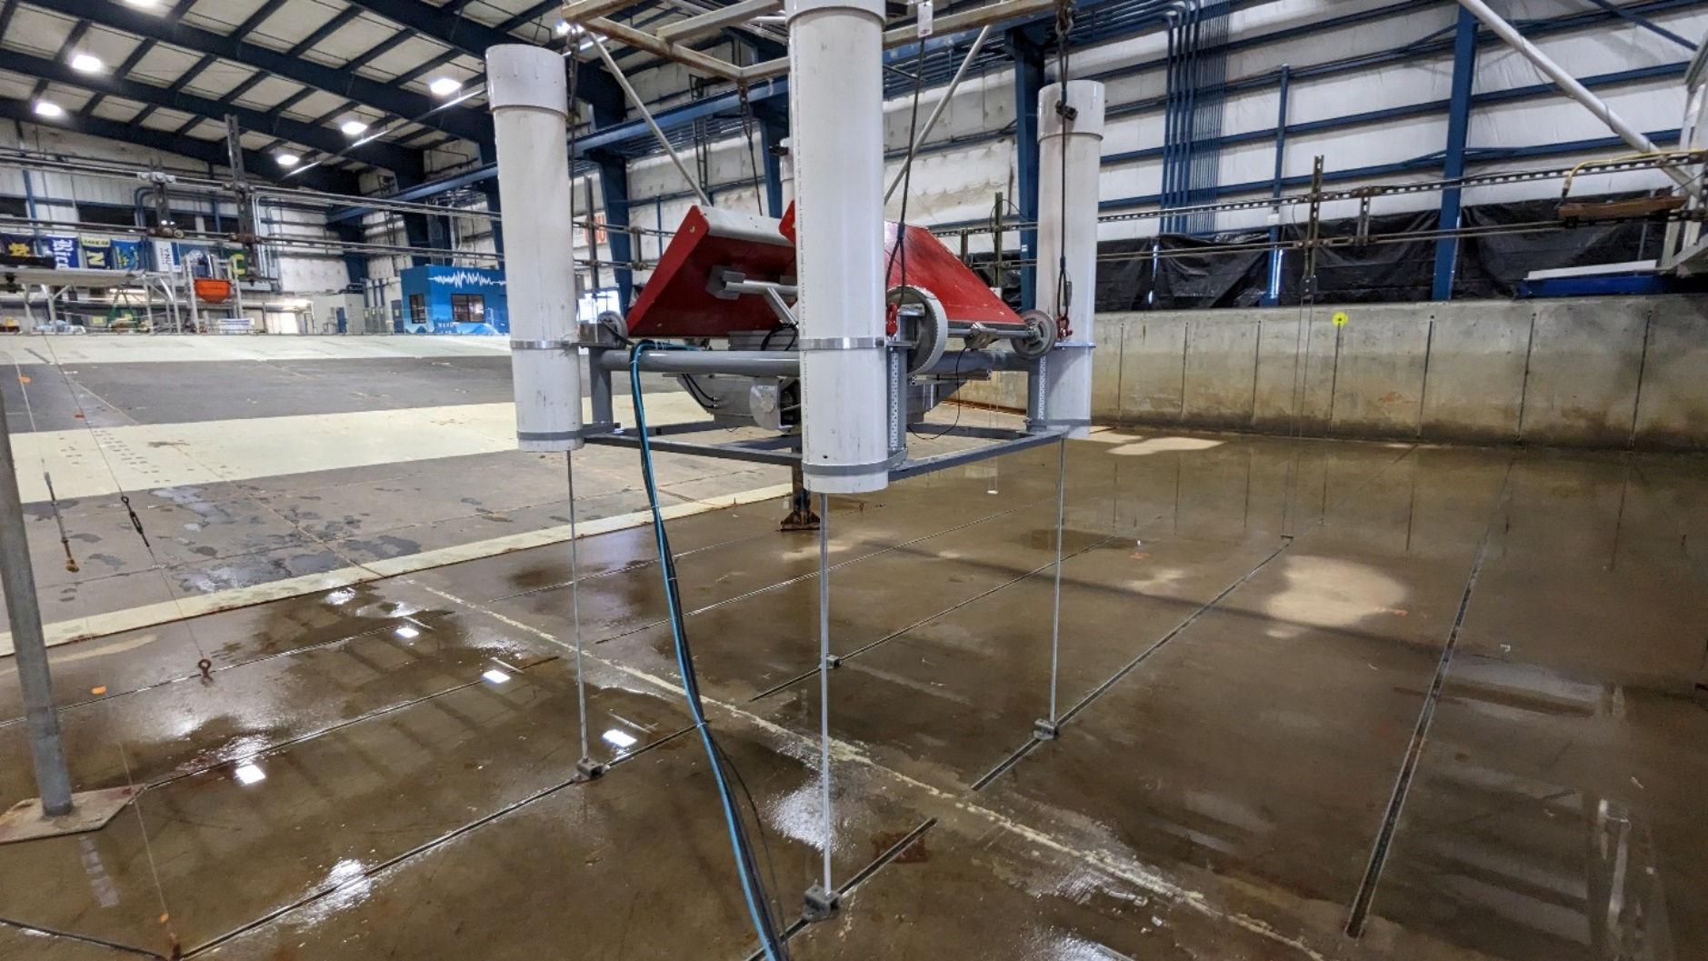

Figure : FOSWEC2 being lowered down over threaded rods

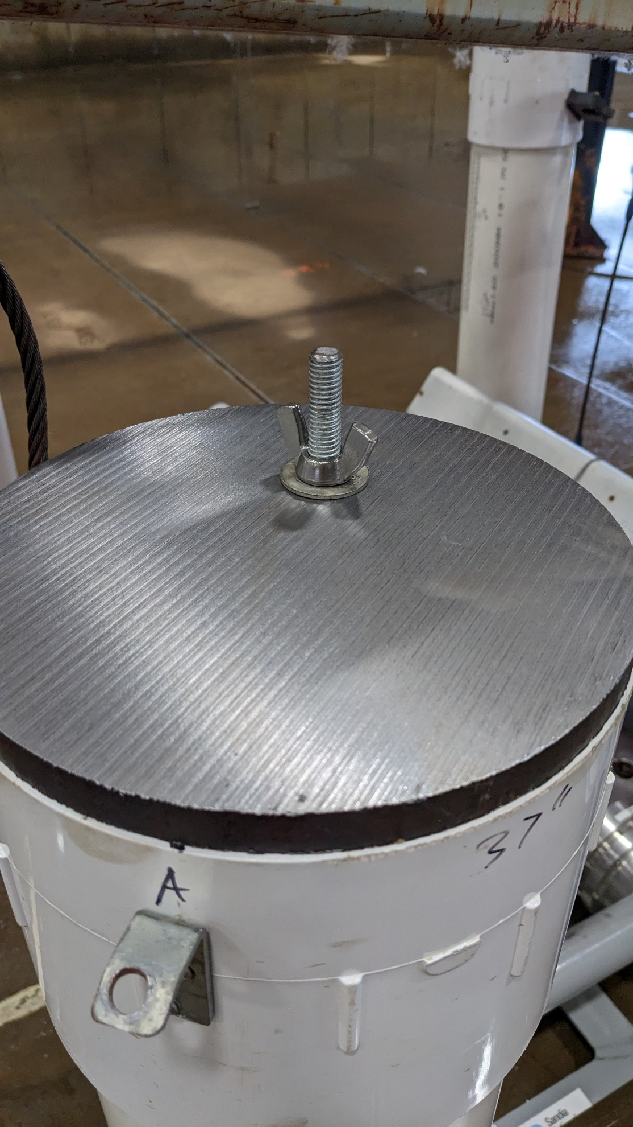

Figure : Threaded rods pass through steel plates and wingnuts are used to secure the FOSWEC2 to the basin floor

# Wave Basin Testing

System Identification no wave tests were conducted first. Small improvements to the data collection and GUI were performed throughout with changes tracked in git.

Experiment Reference1 was conducted to characterize the system using input output methods. Three white noise realizations of drive current command were used to excite the flap with a drive measured torque while encoder position was recorded. An admittance model was then estimated using the MATLAB system identification toolbox. Admittance is assumed here to be the ratio of flap position and flap torque

$$Y\left(ω\right)=\frac{θ_{f}(ω)}{τ_{f}(ω)}=\frac{θ_{m}(ω)}{τ_{m}(ω)N^{2}}$$

where $Y\left(ω\right)$ is the admittance, $θ_{f}\left(ω\right)$ is the angular position at the flap, $τ_{f}(ω)$ is the torque at the flap, $θ_{m}\left(ω\right)$ is the angular position at the motor, $τ_{m}(ω)$ is the torque at the motor, and $N$ is the gear ratio between the motor and flap which is $N=\frac{75}{20}=3.75$. Figure 28 shows this admittance estimate for trials two through seven of the Reference1 experiment.

Figure : FOSWEC2 flap admittance, estimated flap rotational position to flap torque

From previous experimental testing we encountered a resonance in the structure that occurs in higher frequencies than the wave frequencies of interest. This limits the gains for feedback, particularly in the velocity feedback. To identify this resonance frequency with the hope of designing a filter to mitigate it a bandlimited white noise block in Simulink was employed. Two heights of PSD of white noise were used, namely 0.003 W and 0.006 W. Because the feedback signal of interest is velocity, the resulting angular velocity of each flap was analyzed individually and then together. Figure 29 shows the resulting velocity power spectral density with the strongest component at ~50 Hz. This could be used to fairly quickly identify resonance frequencies to target with filters on a feedback loop.

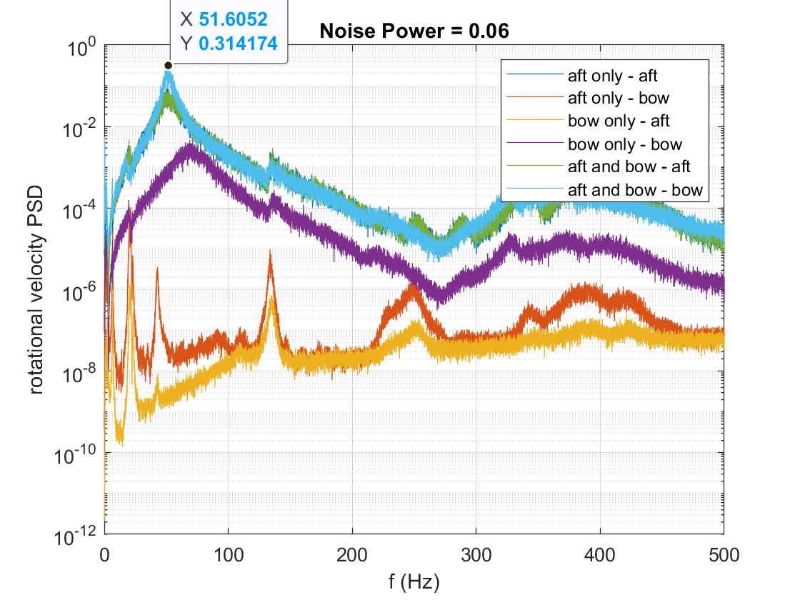

Figure : Rotational velocity PSD for Bandlimited white noise current input

A chirp current reference input was given to one flap at a time and the resulting position was logged. This time-domain data was used to create a transfer function representing a single input single output (SISO) system with current the input and angular motor position the output. This SISO system was then fed the input time series with the results shown in Figure 30.

Figure : tfest was used to create a 4th order transfer function describing the system

The same transfer function was then used with a white noise input and compared to experimental output as shown in Figure 31.

Figure : Comparison of experimental results with transfer function results for chirp identification

|  |  |  |  |  |  |  |  |  |  |  |
| --- | --- | --- | --- | --- | --- | --- | --- | --- | --- | --- |
| **FOSWEC2 Wave Conditions** | | | |  |  | 3/22/2023 |  |  |  |  |
| **Water Depth 1m** | | |  |  |  |  |  |  |  |  |
|  |  |  |  |  |  |  |  |  |  |  |
| **Regular** | |  |  |  |  | **Regular waves**  Heading: 0 deg  Run time: 120 min  **JONSWAP waves**  Repeat period: 300 s  Heading: 0 deg  Run time: 20min  **Chirp**  Start at f0, progress linearly to f1, and reverse  Run time: 10 min  Heading: 0 deg  **Pink**  Repeat period: 300 s  Heading: 0 deg  Run time: 20min  Each wave height will have three different phase realizations | | | | |
|  |  | **H (m)** | | |  |
|  |  | **0.086** | **0.136** | **0.186** |  |
| **T (s)** | **1.25** | R1A | R1B | R1C |  |
| **1.55** | R2A | R2B | R2C |  |
| **1.94** | R3A | R3B | R3C |  |
| **2.63** | R4A | R4B | R4C |  |
| **3.89** | R5A | R5B | R5C |  |
|  |  |  |  |  |  |
|  |  |  |  |  |  |
|  |  |  |  |  |  |
| **JONSWAP** | | **Gamma** | **3.3** |  |  |
|  |  | **Hm0 (m)** | | |  |
|  |  | **0.086** | **0.136** | **0.186** |  |
| **Tp (s)** | **1.25** | J1A | ~~J1B~~ | ~~J1C~~ |  |
| **1.55** | J2A | J2B | ~~J2C~~ |  |
| **1.94** | J3A | J3B | ~~J3C~~ |  |
| **2.63** | J4A | J4B | J4C |  |
| **3.89** | J5A | J5B | J5C |  |
|  |  |  |  |  |  |
|  |  |  |  |  |  |
| **Chirp** | |  |  |  |  |
|  | f0(Hz) | 1.5 |  |  |  |  |  |  |  |  |
|  | f1(Hz) | 0.05 |  |  |  |  |  |  |  |  |
|  | H(m) | **0.086** | **0.136** | **~~0.186~~** |  |  |  |  |  |  |
|  | Name | ChirpA | ChirpB | ~~ChirpC~~ |  |  |  |  |  |  |
|  |  |  |  |  |  |  |  |  |  |  |
|  |  |  |  |  |  |  |  |  |  |  |
| **Pink** | |  |  |  |  |  |  |  |  |  |
|  | f0(Hz) | 1.5 |  |  |  |  |  |  |  |  |
|  | f1(Hz) | 0.05 |  |  |  |  |  |  |  |  |
|  |  | **H (m)** | | |  |  |  |  |  |  |
|  |  | **0.086** | **0.136** | **~~0.186~~** |  |  |  |  |  |  |
| **Phase** | **1** | Pink1A | Pink1B | ~~Pink1C~~ |  |  |  |  |  |  |
| **2** | Pink2A | Pink2B | ~~Pink2C~~ |  |  |  |  |  |  |
| **3** | Pink3A | Pink3B | ~~Pink3C~~ |  |  |  |  |  |  |



Figure : Basin Layout

# Summary of FOSWEC2 updates

* Encoders were changed from Sick to Heidenhain
* Scaling was changed on gauge pressure sensors
* Simulink model was redesigned and updated
* Graphical User Interface was developed to interact with FOSWEC2
* Motor operation mode changed from “profile torque” (ID4) to “cyclic torque” (ID10)

# Future Work

* Repair/replace flaps and or flap shafts
* Repair/replace leaks in electrical connections to hull
* Investigate changing flap encoder

# Appendix A

|  |  |  |  |  |  |  |
| --- | --- | --- | --- | --- | --- | --- |
|  | cts | psi meas | psi assumed  slope&offset | absolute error | psi meas  slope&offset | absolute error |
|  | 16225 | 0.0087 | 0.0063 | 0.0024 | -0.0674 | 0.0761 |
|  | 17504 | 1.1262 | 1.1656 | 0.0394 | 1.0919 | 0.0343 |
|  | 18775 | 2.3068 | 2.3177 | 0.0109 | 2.2439 | 0.0629 |
|  | 19949 | 3.1199 | 3.3818 | 0.2619 | 3.3079 | 0.1880 |
|  | 21156 | 4.4818 | 4.4758 | 0.0060 | 4.4019 | 0.0799 |
|  | 22506 | 5.575 | 5.6994 | 0.1244 | 5.6255 | 0.0505 |
|  | 23644 | 6.603 | 6.7309 | 0.1279 | 6.6569 | 0.0539 |
|  | 24737 | 7.5827 | 7.7216 | 0.1389 | 7.6476 | 0.0649 |
|  | 25686 | 8.6265 | 8.5818 | 0.0447 | 8.5077 | 0.1188 |
|  | 26936 | 9.6087 | 9.7148 | 0.1061 | 9.6407 | 0.0320 |
|  | 28030 | 10.5172 | 10.7064 | 0.1892 | 10.6322 | 0.1150 |
|  | 29160 | 11.6502 | 11.7306 | 0.0804 | 11.6564 | 0.0062 |
|  | 30170 | 12.5754 | 12.6461 | 0.0707 | 12.5718 | 0.0036 |
|  | 31273 | 13.5546 | 13.6458 | 0.0912 | 13.5716 | 0.0170 |
|  | 31838 | 14.2776 | 14.1580 | 0.1196 | 14.0837 | 0.1939 |
|  | 32565 | 14.7419 | 14.8169 | 0.0750 | 14.7426 | 0.0007 |
|  | 31238 | 13.5133 | 13.6141 | 0.1008 | 13.5398 | 0.0265 |
|  | 30152 | 12.5157 | 12.6298 | 0.1141 | 12.5555 | 0.0398 |
|  | 29029 | 11.5022 | 11.6119 | 0.1097 | 11.5377 | 0.0355 |
|  | 27921 | 10.4957 | 10.6076 | 0.1119 | 10.5334 | 0.0377 |
|  | 26838 | 9.4909 | 9.6260 | 0.1351 | 9.5519 | 0.0610 |
|  | 25573 | 8.5142 | 8.4794 | 0.0348 | 8.4053 | 0.1089 |
|  | 24467 | 7.5073 | 7.4769 | 0.0304 | 7.4029 | 0.1044 |
|  | 23539 | 6.5044 | 6.6357 | 0.1313 | 6.5618 | 0.0574 |
|  | 22296 | 5.5083 | 5.5091 | 0.0008 | 5.4352 | 0.0731 |
|  | 21316 | 4.5018 | 4.6208 | 0.1190 | 4.5469 | 0.0451 |
|  | 20194 | 3.5017 | 3.6038 | 0.1021 | 3.5300 | 0.0283 |
|  | 18971 | 2.4999 | 2.4953 | 0.0046 | 2.4215 | 0.0784 |
|  | 17987 | 1.5046 | 1.6034 | 0.0988 | 1.5296 | 0.0250 |
|  | 16885 | 0.5062 | 0.6046 | 0.0984 | 0.5308 | 0.0246 |
|  | 16331 | 0.0036 | 0.1024 | 0.0988 | 0.0287 | 0.0251 |
|  |  |  |  | mean abs error | | mean abs error |
|  |  |  |  | 0.0897 |  | 0.0603 |
| slope | psi/cts | 9.0636E-04 | 9.0640E-04 |  | 9.0636E-04 |  |
| offset | psi | -14.7731 | -14.7000 |  | -14.7731 |  |
|  | rsq | 0.999716984 | 1.0000 |  | 0.99971698 |  |